# Requirements

**BRAINSTORMING IDEAS**

<https://miro.com/app/board/o9J_kjKpWic=/>

## Introduction by Mikaela

**The purpose of the requirements phase is to allow for developers to work out what the application should be able to do. It is important to understand what the users would like the application to do rather than the developer deciding what is required.**

**You can write a bit about your project area. Each paragraph has a blank line between it and the previous paragraph**

The game we are developing is “Animal Simulator”. It has 3 main genres: open world, sandbox, and simulation. For now, we will keep the game single player because it is less complex and more feasible given the amount of time we have. Multiplayer will require a lot of networking technologies and more coding.

We will be using low-poly graphics because they aren’t that graphics intensive and besides, they are nice to look at. The models have less polygons and they are grouped in a mesh together, creating a cartoonish look with different shapes. Pastel colours, deep blacks, and vibrant colours work well with this graphics style.

The game doesn’t have a story, because in most cases, sandbox games focus more on independence, freedom, and creativity. However, the game has objectives and unlockables, so it will give the player some sense of achievement and something to strive towards. For example, if they get a certain amount of points, a message will appear onscreen that will compliment and praise the player. The player will be able to unlock new skins or even a new animal.

## Requirements gathering

### Similar applications by Mikaela

**Look at and document three similar applications. Be sure to include the following for each:**

GAME 1 - GOAT SIMULATOR

* **Descriptions**

Reference: https://store.steampowered.com/app/265930/Goat_Simulator/

*“Gameplaywise, Goat Simulator is all about causing as much destruction as you possibly can as a goat. It has been compared to an old-school skating game, except instead of being a skater, you're a goat, and instead of doing tricks, you wreck stuff. Destroy things with style, such as doing a backflip while headbutting a bucket through a window, and you'll earn even more points! Or you could just give Steam Workshop a spin and create your own goats, levels, missions, and more! When it comes to goats, not even the sky is the limit, as you can probably just bug through it and crash the game.”*

* **+ Advantages / - Disadvantages**

Price

**+** You get exactly what you paid for. You can play as a goat.

**-** I think the price should be €4.99 instead of €8.19.

UI

**+** It’s nice and user-friendly.

**+** When you start the game, you see the game title, and the camera moving around to show case the world.

**+** The colour scheme of the main menu matches the grass in the game. After all, goats eat grass.

**+** If you hover over the nav bar, it make some sounds and changes colour.

**+** I like how the nav bar is placed at the left side and when you click on let’s say Options, the Options screen is placed on the right side and there’s space in the middle to showcase the game. The menu is also slightly transparent.

**-** Nothing bad.

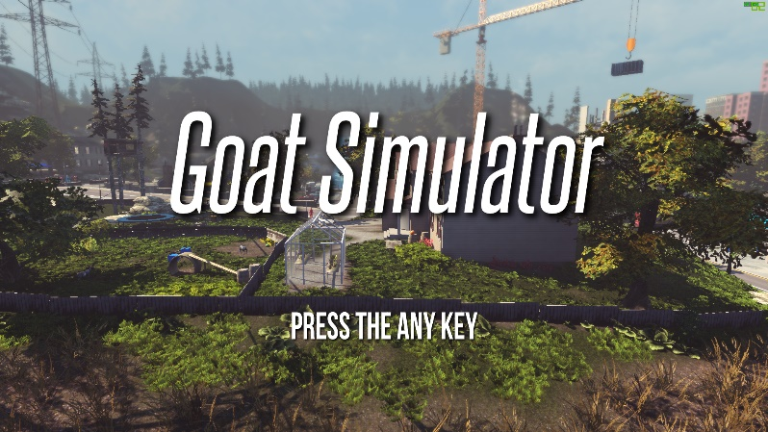 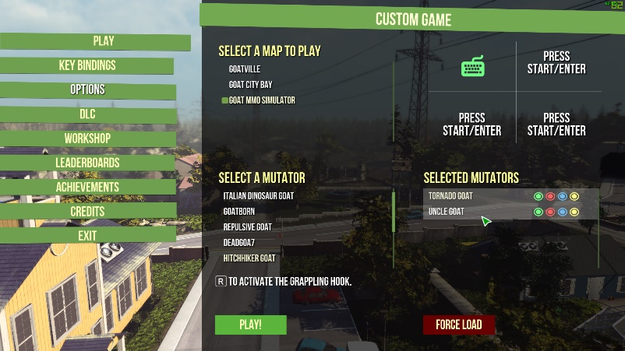

Graphics

**+** Nice looking graphics, trees have plenty of foliage, good lighting and nice texture on the rocks

**-** Not much to say, other than that the face of the goat looks weird and some of the AI’s faces looks like they’re from early 2000s graphics.

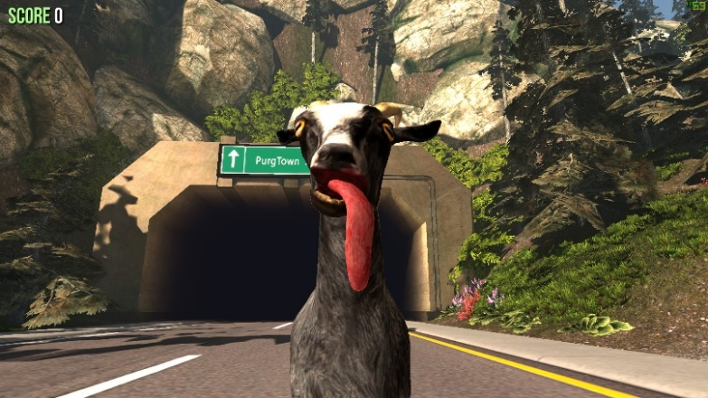 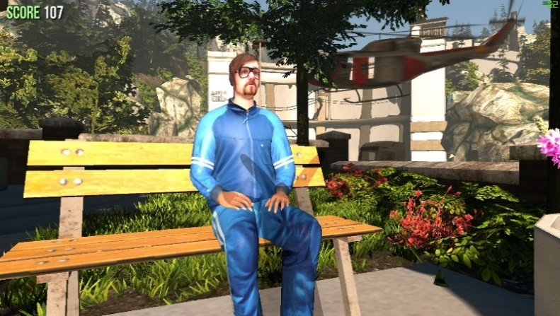

Gameplay / Mechanics

**+** The rag-doll effect makes everything look more satirical, and sillier.

**+** 3rd person mode allows the player to see what skins they have equipped.

**+** Fun gameplay that allows you to destroy as many things you want, and even sacrifice 5 people to Satan.

**+** Jump, walk, zoom in and out with the camera, make goat noises and use your tongue to grab things.

**-** The ragdoll and gravity can sometimes launch you somewhere and it’s easy to get stuck.

**-** There are bugs; however, they are intentional to make the game sillier.

**-** It gets boring quickly.

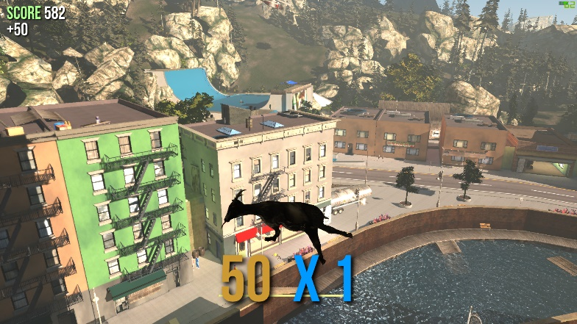 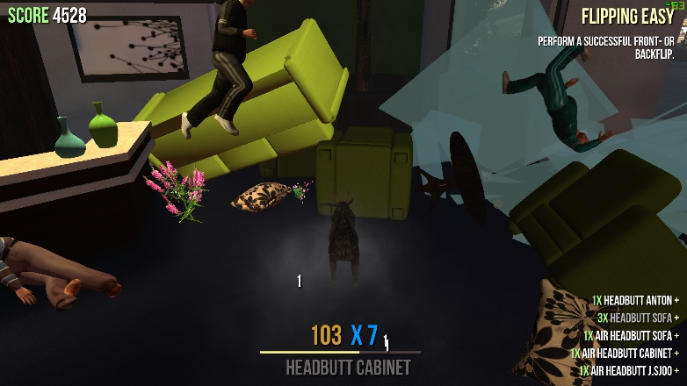

Level Design

I don’t think there is any. If the player gets a certain amount of points, they can unlock skins. The perspective of the player is in 3rd person mode, so the player can see what skins they have equipped after unlocking them. It also allows you to see how silly the goat’s movement looks.

Objectives

**+** Express your freedom, creativity and independence.

**+** Quests and achievements to unlock more stuff like skins, and to go into different maps.

**+** Mini games such as racing.

**-** Nothing much to say.

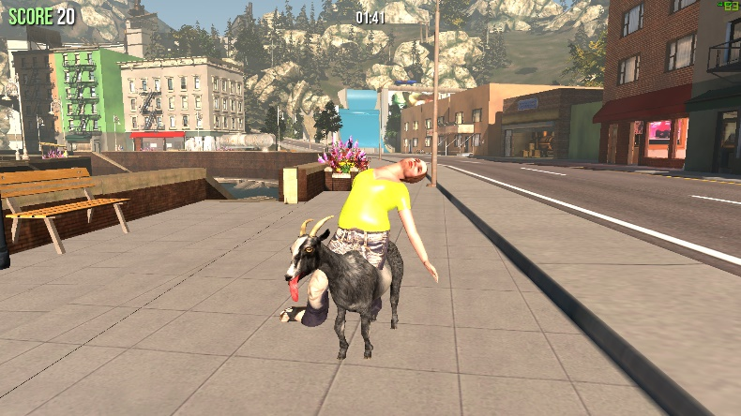 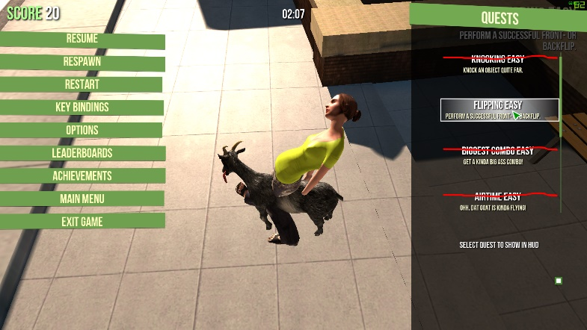

Multiplayer/Singleplayer

**-** There is no multiplayer, but it would be fun if there were other goats in the world. Imagine 4 goats destroying the whole world. Jeez!

Sound

**+** Silly indie ukulele music with a trumpet to make it sound sillier.

AI

**+** People will notice you and run away from you if you destroy stuff.

**-** Not that realistic, but sufficient.

Replayability

It’s replay-able in short sprints, but I don’t think I’d be able to play it everyday for hours and hours.

GAME 2 – THE ISLE

* **Descriptions**

REFERENCE: <https://store.steampowered.com/app/376210/The_Isle/>

*“The Isle is intended to be a gritty, open-world survival horror game. Explore vast landscapes of dense forest and open plains, traverse treacherous mountains, and wade through dark swamps where horrors lurk. Hidden within are ruins that hold insight as to what came before. Through it all, keep in mind there is only one goal: survive.”*

* **+ Advantages / - Disadvantages**

Price

**+** For €19.99 you get a good gaming experience of a simulated dinosaur world.

UI

**+** Nice looking main menu. The moss around it and that stutter screen gives it a Jurassic Park feel.

**+** The game is showcased from different camera angles.

**+** The HUD is dynamic, but can be set to static.

**-** The camera angles and the tablet could initially make the wrong impression. I thought it would be like Jurassic Park and that I’m an animal expert hunting or examining dinosaurs.

**-** Limited hints don’t tell you how to make eggs or make a burrow.

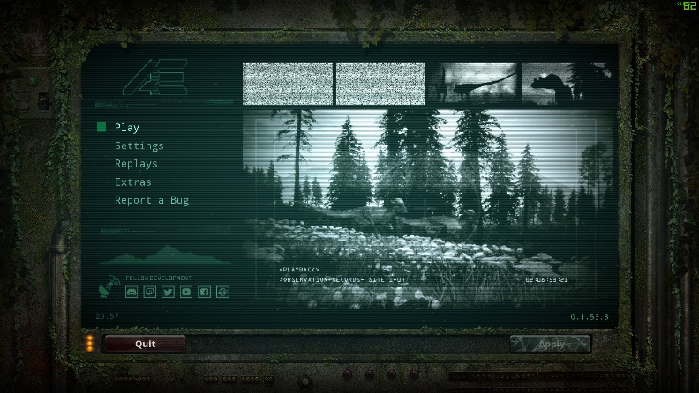 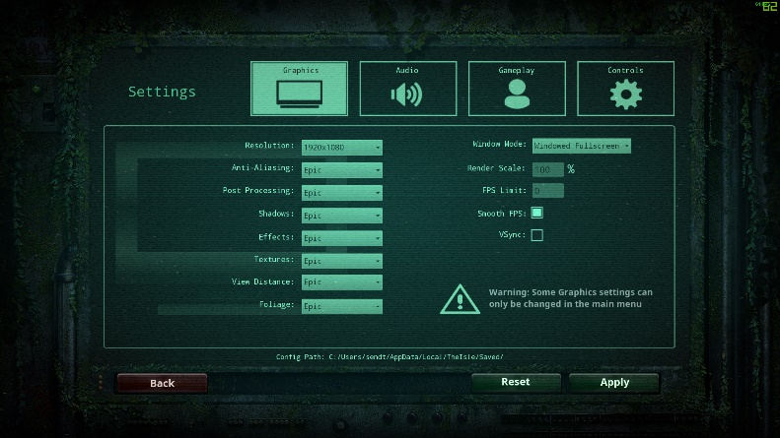

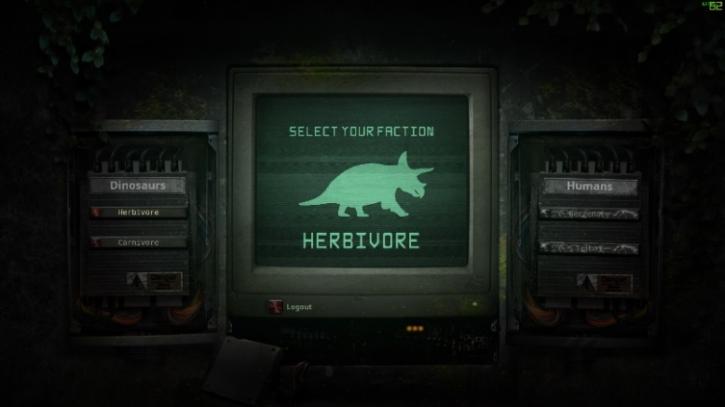 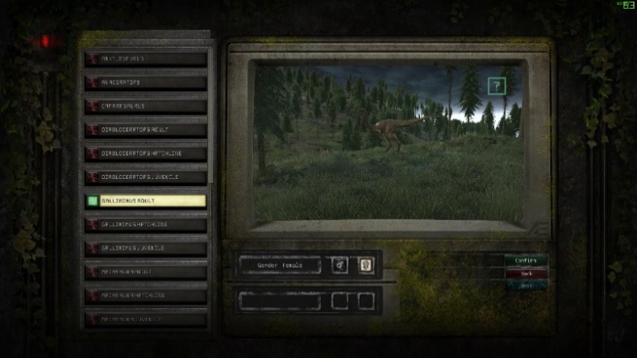

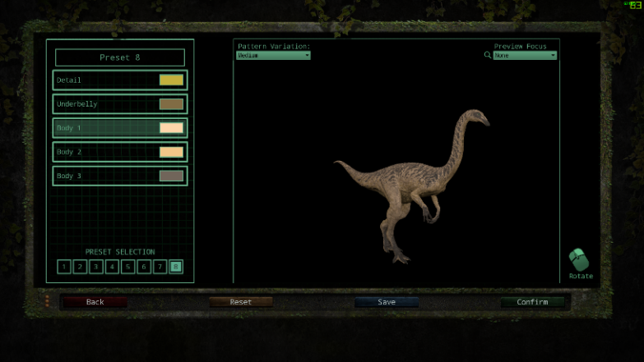 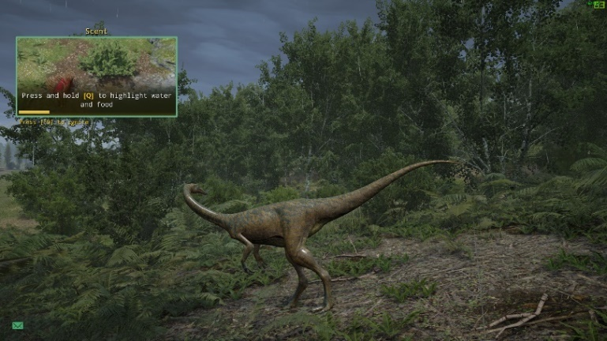

Graphics

**+** Ability to change the dinosaur screens make it more realistic.

**+** Beautiful scenery and trees have good foliage.

**+** Screen is dark during the night time, which is of course realistic.

**-** Nothing bad to say.

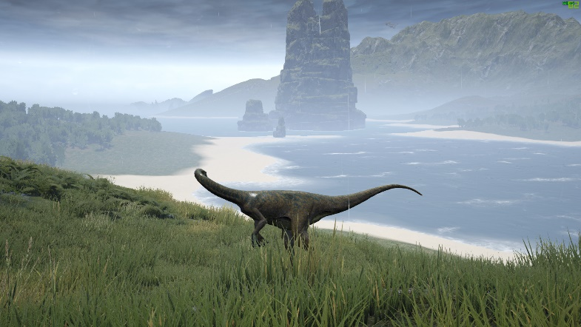 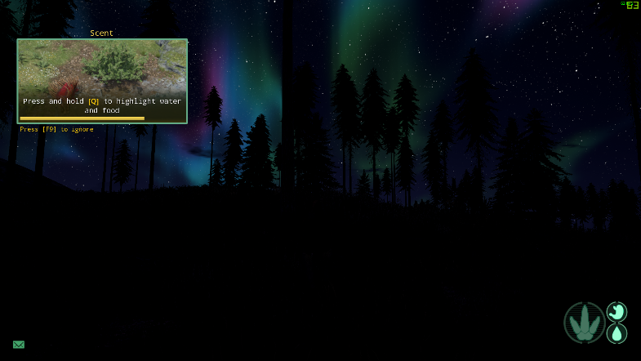

Gameplay / Game Mechanics

**+** Select different dinosaurs and change the skin patterns.

**+** Join servers and chat with other players.

**+** Jump, walk, crouch, eat, drink, make dinosaur noises, make babies, and make a home.

**+** Fall damage causes broken bones.

**+** You can die, attack and kill other dinosaurs.

**-** The game doesn’t give you hints on how to make a home or make babies.

Level Design

**+** It focuses on survival and PVP.

**+** Landscapes and environments are rendered in a realistic style.

**+** Game field has an open-world feel due to its large size.

**+** Very nice ambient sounds of nature.

**+** Each dinosaur has unique sounds e.g. one sound for calling others, another sound for warning others.

**-** Nothing bad to say.

AI

**+** The AI is quite smart ,and carnivores will hunt and attack you if you’re a herbivore.

**-** Only 4 types of dinosaur AI that you can find in the server.

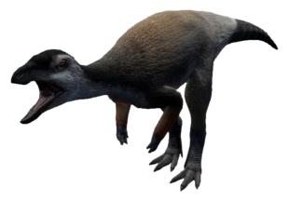 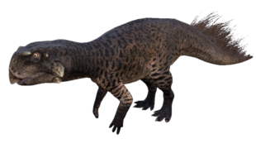

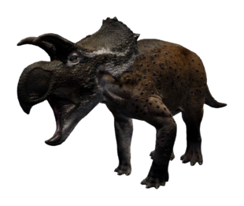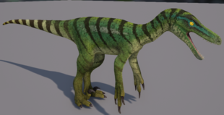

Objectives

**+/-** The main objective is if the player is a baby dinosaur, they must grow by eating and drinking water. Then they make a nest, have babies, and help them survive. If they die, they can play as another baby.

Multiplayer/Singleplayer

**+** Ability to create and host your own server, and add mods.

**+** Option to filter out server and map settings.

**+** Global, local, team and group text chat.

**-** There is no single player. Several players have expressed interest in a single player mode.

**-** Heavily focuses on PVP and not everybody likes PVP; some would rather play in a PVE server.

**-** Slow server search. Game mode should have a drop-down menu instead of a placeholder.

**-** Very limited official servers.

**­-** No voice chat.

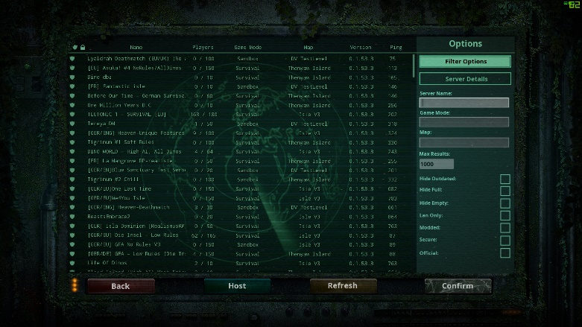 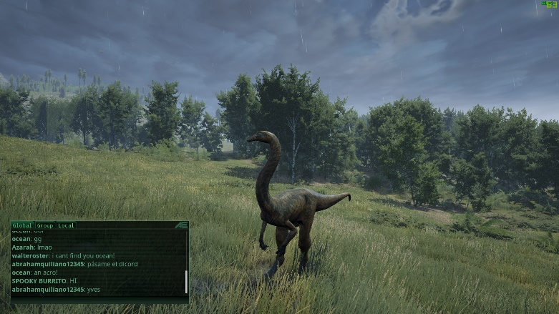

Replayability

**+** Fun to play with friends.

**-** It’s replay-able for a few days, but after that it gets boring quite quickly if you play by yourself.

GAME 3 – WILDCRAFT 3D ONLINE SIMULATOR

* **Descriptions**

REFERENCE: https://play.google.com/store/apps/details?id=com.turborocketgames.wildcraft

“*Explore nature as a wild animal and raise a family in the wilderness in Wildcraft, a new RPG adventure set in a huge 3D landscape!*

*Start your adventure as a wolf, fox, lynx and more, and take your family on a new adventure. Play with friends in multiplayer games and form animal families to protect your cubs from enemies. Unlock new animal breeds as your family legacy grows in Wildcraft!”*

* **+ Advantages / - Disadvantages**

Price

**+** It’s free.

**-** It has many ads and to remove them you must pay.

**-/+** Like most apps that are free online you can pay for items online to help you progress in game.

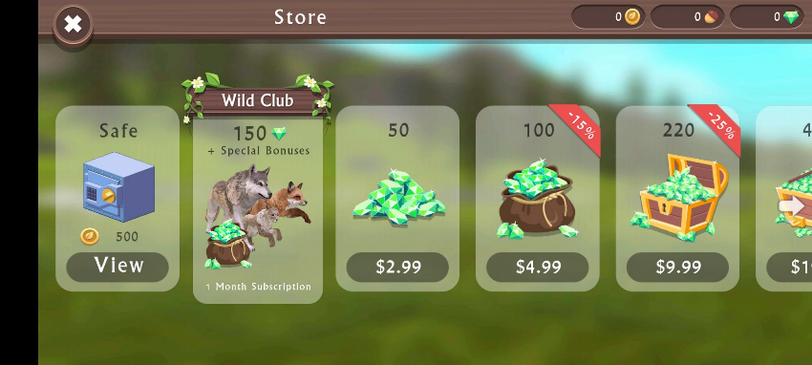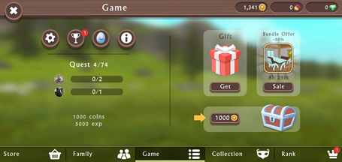

UI

**+** It looks nice and nav menus have a brown texture and some have leaves over them to match the game with nature.

**+** The UI isn’t too small for the player’s finger. It’s user friendly and easy to navigate around. There are plenty of tutorials and head pointers.

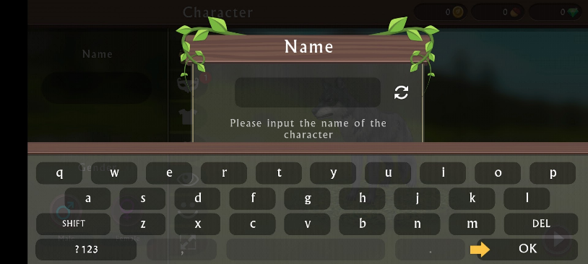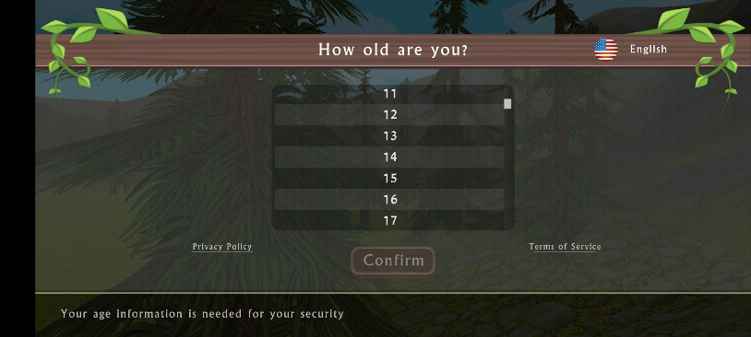

Graphics

**+** Mobile graphics seems to be becoming a bit more complex and better each year. Wildcraft’s graphics seems to be on par with the graphics of Grand Theft Auto: San Andreas PS2 and mobile version, if not better.

**+** You can configure the settings of the graphics.

**+** The graphics are high definition, and the trees have plenty of foliage.

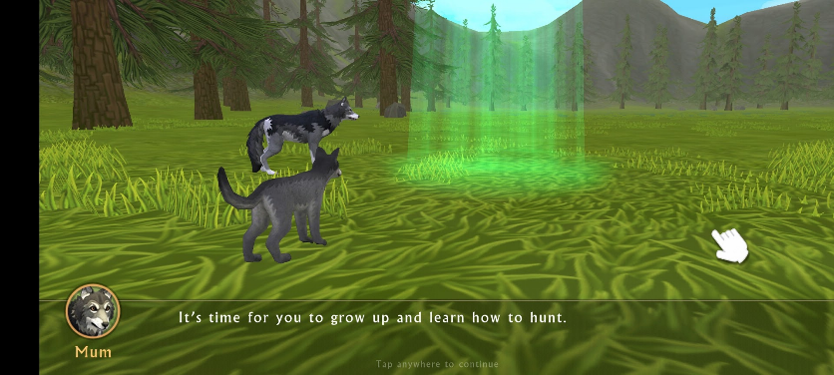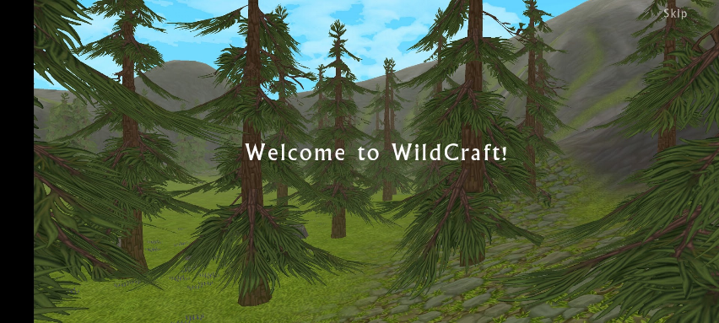

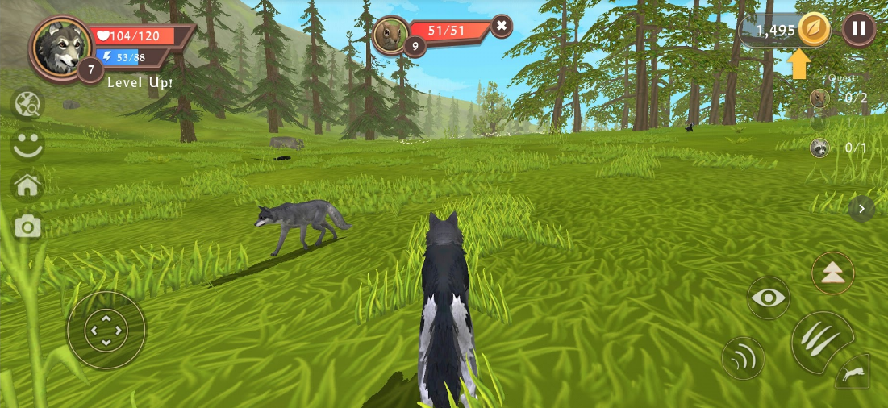

Gameplay / Game Mechanics

**+** Select different animals, change their skin patterns and wear cosmetics.

**+** Join servers and interact with other players.

**+** The controls are jump, walk, make animal noises, sprint and attack.

**+** There is animal vision that allows the player to look for prey.

**+** You can make a family to increase your pack, hunt animals to heal and get points.

**-** The running animation looks unrealistic - it looks like you’re skating.

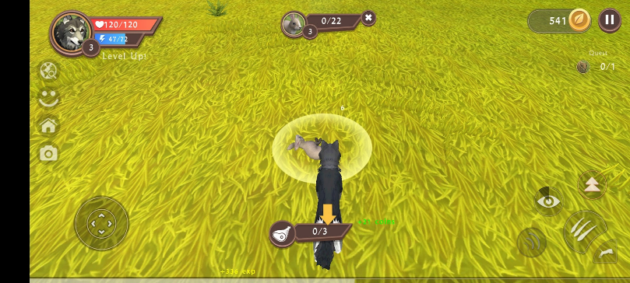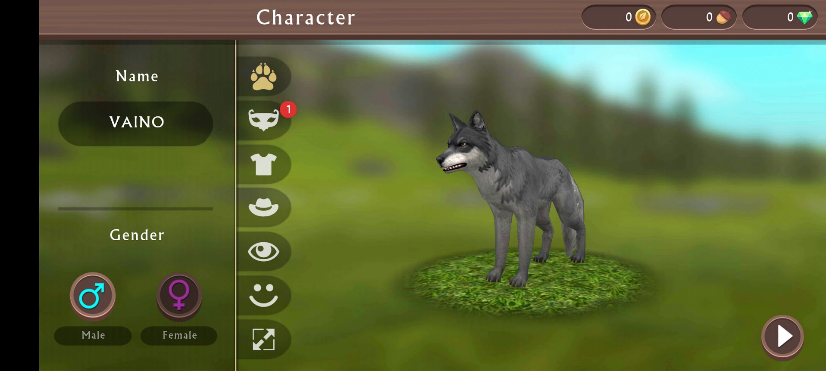

Level / Game Design

**+** When you get a certain amount of experience points you level up and you get 3 items.

**+** There is a levelling system, and you get points by completing mini objectives or hunting other animals. The higher your level the more bonus content you unlock.

**+** There is a coin system, and it increases by completing the objectives and levelling up. You can buy stuff in the market like skins, potions and cosmetics.

**+** There is health and stamina system. Other animals and players can attack you and if your health reaches 0 you die. You then respawn as a different animal. If you have a cub or another animal in your pack, you won’t lose your progress.

**+** Character creation system where you can enter your name, select different animals and configure the body of the animals.

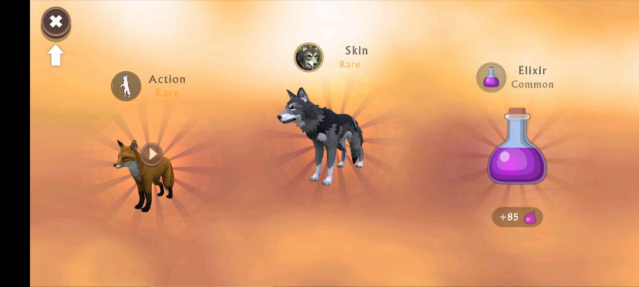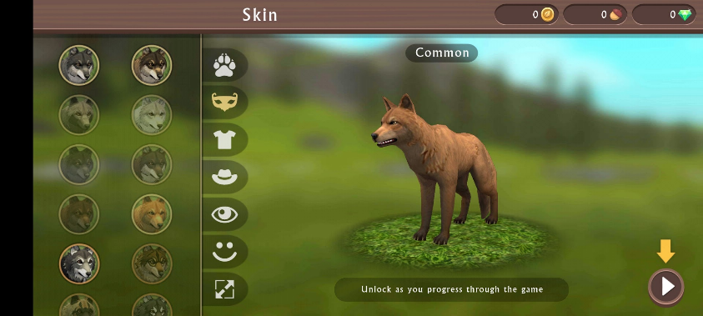

AI

**+** There are AI scattered around the world. You can track them down using the wolf’s vision and scent tracker. If you’re near a rabbit battle music begins and the rabbit will start running away.

**+** You can increase your pack by fighting with other animals of the same pack. They need to be tamed.

Objectives / Achievements

**+** There is a ranking system and for each rank you attain you can select a gift as a reward.

**+** There are mini objectives shown at the right corner or the middle top of the UI.

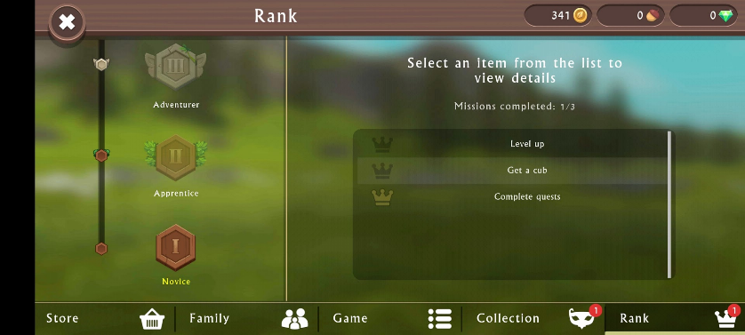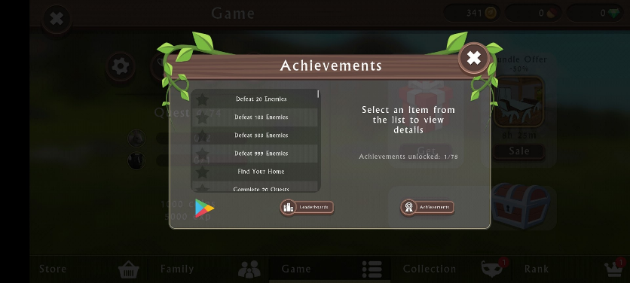

Singleplayer / Multiplayer

**+** You can play in singleplayer mode which has a story mode.

**+** You can play in multiplayer mode and do mini objectives and interact with other players.

**-** There is no chatting system.

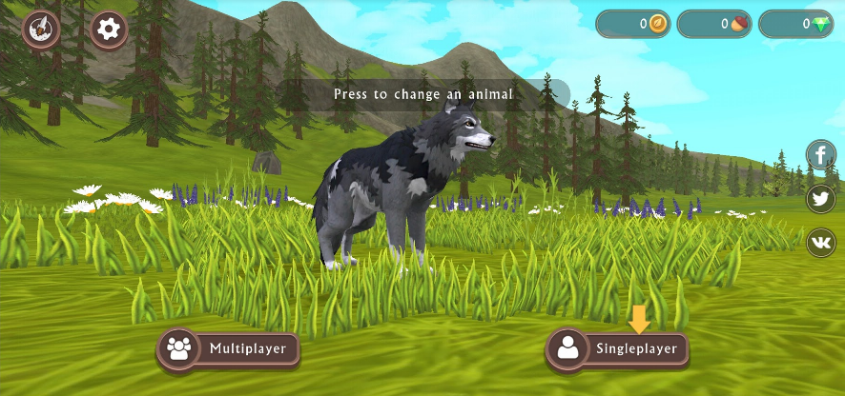

Replayability

**+** Depending on the player it can be fun and some players enjoy just hunting animals repeatedly.

**+** Being able to interact with other players and making friends usually increases the replaybility of the game.

### Personas by Mikaela + Aisling

These are fictional characters to help the developer understand the users’ needs. They also help identify who the relevant users are.

**For reference and to get ideas:**

<https://medium.com/@fernandocomet/the-player-persona-template-d171e3e0c05d>

<https://www.myersbriggs.org/my-mbti-personality-type/mbti-basics/judging-or-perceiving>

**Persona 1:**

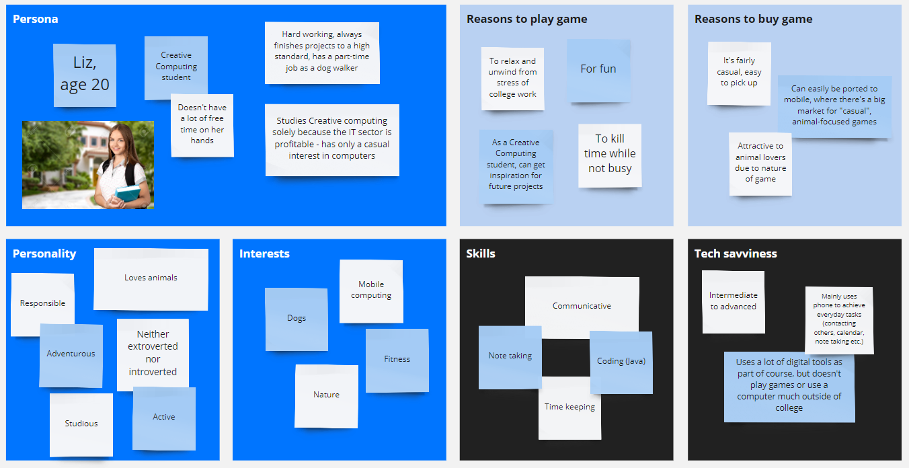

**Persona 2:**

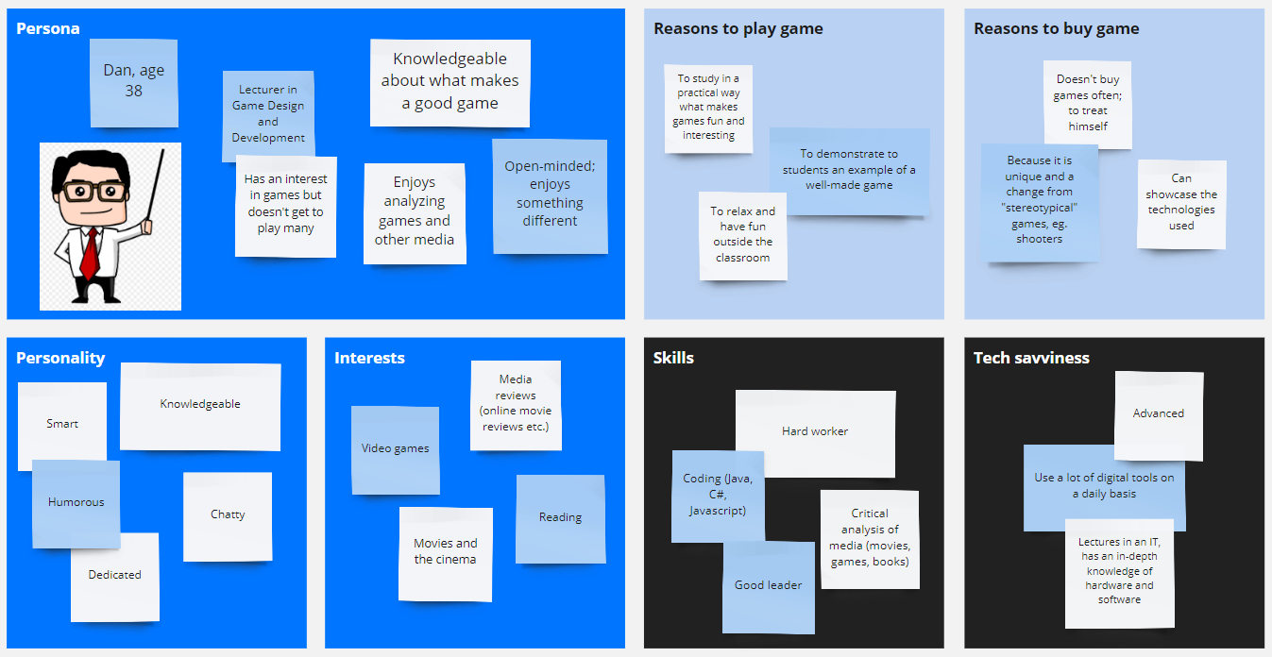

**Persona 3:**

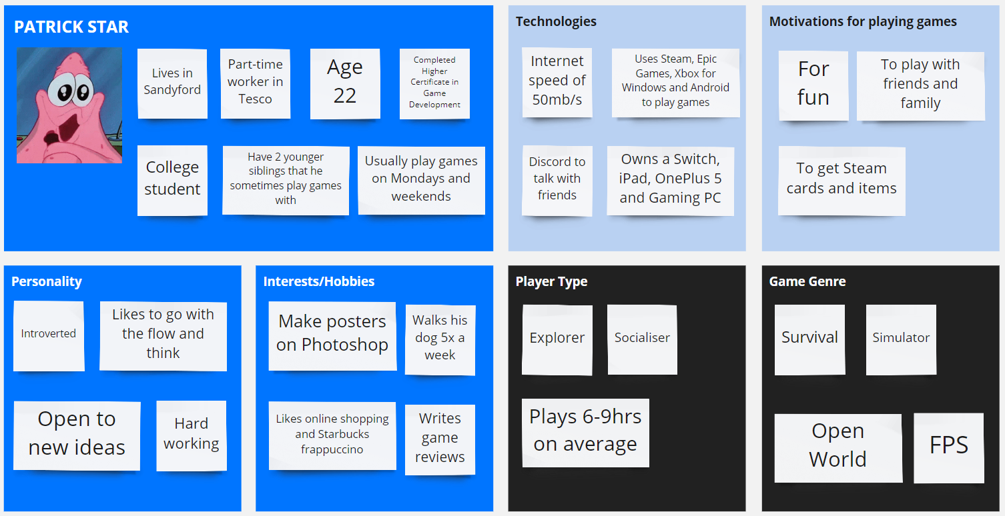

**Persona 4:**

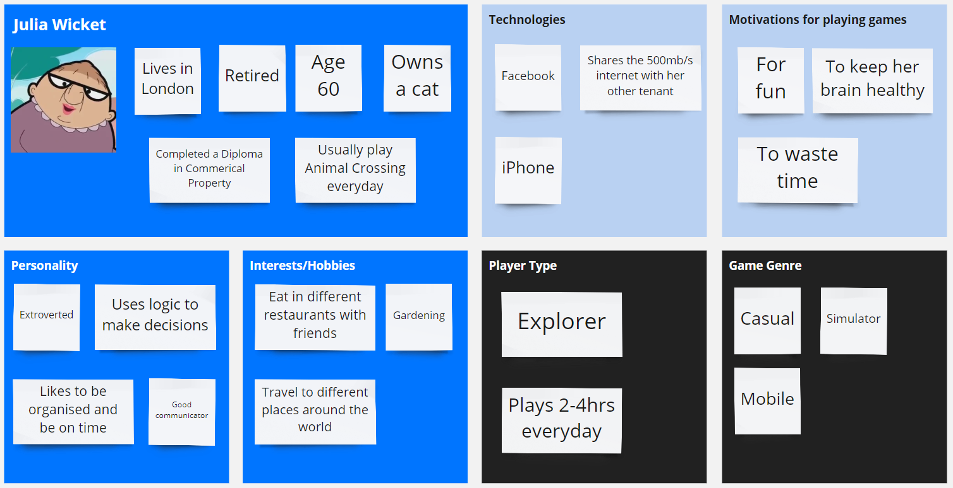

### Interviews by Mikaela + Aisling

Conduct interviews with 3 or 4 users to find out what the important features for them for the app are. There may be various issues that arise in multiple interviews. These can be grouped together into several themes.

**(20/Oct/2020) Mikaela conducted this interview with a 20-year-old gamer from Oxford, UK**

|  |  |
| --- | --- |
| **Do you play games?**  Yes  **Apart from playing games, what other hobbies do you have?**  I do DIYs I like to go on dinner dates  **Do you have any siblings and how many?**  Yes, I have 1 brother and 2 sisters  **Do you play games with them?**  No  **How old are you?**  20 years old  **What is your occupation?**  Unemployed, looking for work  **What is your highest level of education?**  A-Levels on engineering and business  **What is your most preferred method to communicate with other players and why?**  Discord because it's the best and it has community features and I'm a community owner of a Discord server for Arma 3 and Rust over a year  **What is your internet speed Mb/s?**  135Mb/s  **What games do you typically buy?**  Simulation  Survival  **What games do you typically buy and why?**  Simulation  Survival  I just like those games  **Do you read games reviews?**  Yes, so I can find out people’s opinions to see if it’s a good purchase  **Do you write reviews for games?**  I don’t like to write reviews because it’s unnecessary | **What are your main reasons for playing games?**  They're fun, learning valuable skills like logic, I like being a game owner and dealing with other people's problems and I like the power and I meet many women and have many female gamer friends and I love them so much  **What days do you usually play games?**  The whole week  **How many hours do you play games each day on average?**  Around 6 - 8 hours  **Do you sometimes have trouble sleeping?**  Yes, but it's not because of gaming but due to mental problems  **Do you think games can cause you to sleep poorly?**  No because I am in control of my own body, if I want to sleep, I will sleep  **How many hours do you sleep each day on average?**  5 - 8 hours sometimes up to 10 hrs  **Do you play simulator games?**  Yes  **How often do you play Simulator games?**  It depends on your mood and how bored I am  **How often do you play Open World games?**  Not as often as I used to  **Do you play Sandbox games?**  Not as often as I used to  **What players types that describes you best?**  Killers because I like to shoot the hell out of people  Achievers because I like to be the best in the game |

**(20/Oct/2020) Mikaela conducted this interview with a 29 year old gamer from Finland**

|  |  |
| --- | --- |
| **Do you play games?**  Yes  **Apart from playing games, what other hobbies do you have?**  Aquariums, scale models, house plants and gardening, walking  **Do you have any siblings and how many?**  3  **Do you play games with them?**  Yes, we played everyday since I was living at home. But lately, I play with my sister sometimes whenever she comes for a visit.  **How old are you?**  29  **What is your occupation?**  Retired  **What is your highest level of education?**  High School certificate  **What is your most preferred method to communicate with other players and why?**  In-game text because I’m not a native English speaker and it’s just harder to pick it up and the text stays  Voice chat is not that reliable as text like it sometimes cuts off  If someone has an accent it can be difficult  **What is your internet speed Mb/s?**  100Mb/s  **What games do you typically buy and why?**  Strategy games and RPG  Because I’ve been playing them since I was 10 years old back then there were no strategy games on the console  **Do you read games reviews and why?**  Less nowadays than before  I used to read game reviews on physical magazines for more than 15 years for PC games  **Do you write reviews for games?**  Very rarely | **What are your main reasons for playing games?**  Relieve stress and to have something to think about like use your brains  **What days do you usually play games?**  Everyday  **How many hours do you play games each day on average?**  Like around 4 hours  **Do you sometimes have trouble sleeping?**  Yes  **Do you think games can cause you to sleep poorly?**  No  **How many hours do you sleep each day on average including naps times?**  About 9 hours  **Do you play simulator games?**  Yes  **How often do you play Simulator games?**  Once a month  **Do you play Open World games?**  Yes  **How often do you play Open World games?**  Once a week on average  **Do you play Sandbox games?**  Yes  **How often do you play Sandbox games?**  Once a week  **What players types that describes you best and why?**  Explorer because new things usually interest me, and I can explore things in games that you can’t explore in real life e.g. I can’t explore space |

**(25/10/2020) Aisling conducted this interview with a 23-year-old gamer from Dublin, Ireland**

|  |  |
| --- | --- |
| **Do you play games?**  Yes  **Apart from playing games, what other hobbies do you have?**  Cycling, cars, playing guitar  **Do you have any siblings and how many?**  Yes - 2 brothers  **Do you play games with them?**  Yes, sometimes  **How old are you?**  23  **What is your occupation?**  Manager at McDonald’s Tallaght  **What is your highest level of education?**  Level 6 in Hospitality Management  **What is your most preferred method to communicate with other players and why?**  Discord if playing with friends, otherwise no voice communication at all.  **What is your internet speed Mb/s?**  70 Mb/s  **What games do you typically buy and why?**  Multiplayer – fun with friends  Fantasy  Some first-person shooters  **Do you read games reviews and why?**  Not often – not interested  **Do you write reviews for games?**  No | **What are your main reasons for playing games?**  To relax, for fun  **What days do you usually play games?**  Depends on when I have work and/or college  **How many hours do you play games each day on average?**  Roughly around 4 hours each day  **Do you sometimes have trouble sleeping?**  Yes, but not because of games  **Do you think games can cause you to sleep poorly?**  No  **How many hours do you sleep each day on average including naps times?**  About 8 on average  **Do you play simulator games?**  Yes  **How often do you play Simulator games?**  Not very often  **Do you play Open World games?**  Yes  **How often do you play Open World games?**  Very often  **Do you play Sandbox games?**  Yes  **How often do you play Sandbox games?**  Very often  **What player type describes you best and why?**  Casual – I like games but I wouldn’t necessarily forego eating or sleeping to play them instead. |

### Survey by Mikaela

You can create a questionnaire and use the results of the questionnaire as a basis for finding out requirements.

**Google Forms** was used to find the requirements for our game, as well as find our target audience and what kind of gamers they are.

This form was sent out to people who we know play games so they can give us a good understanding of what games they play, their most played games, what gaming platforms they use and what the most important game elements and mechanics for open world sandbox simulator games are.

**Animal Simulator**

**Number of responses: 36**

<https://forms.gle/NBuTSXrZnVfgFXjN8>

**Response Sample:**

**(IN WORD RIGHT-CLICK AND CLICK MACRO-ENABLED WORKSHEET OBJECT AND SELECT OPEN)**



This form was sent out to our classmates and other gamers find the target audience, demographic, behaviour & personalities of people and the technologies used.

**Animal Simulator: Personas**

**Number of responses: 16**

<https://forms.gle/a7r6WCRBq3PgQ4Uv9>

**Response Sample:**

**(IN WORD RIGHT-CLICK AND CLICK MACRO-ENABLED WORKSHEET OBJECT AND SELECT OPEN)**



## Requirements modelling

### Functional requirements by Aisling

Create a numbered list of what the application should be able to do. Start with the most important feature.

TOP 10 Features + brief description:

1. **Sandbox:** the player should be able to move around freely, and do whatever they please within reason. No main story or objective to follow, simply play around, explore, and most importantly, have fun.
2. **Open World:** the player should have ample room to move around and explore. The game world should feel as large in scale as our own world. Boundaries should not be too obvious. Game world should have a “seamless” feeling (that is, no transition between one area and the next – just as in real life).
3. **Points System:** the game should track how many points the player has accumulated by completing tasks, achieving goals, and generally progressing through the game. The player should clearly see how many points they gain from completing an objective, as well as the total points gained.
4. **Choice of Animals:** the player should, after playing as the “default” animal (to be decided), unlock other animals as player characters. They should have the free choice to play as whichever animal they wish.
5. **Visual Descriptions:** when the player views their character’s stats, they should see their animal visually.
6. **Stats:** it should be easy and clear to the player how to view statistics, eg. From a main menu, or pause menu. Statistics might include items such as distance travelled, food eaten, items destroyed etc.
7. **Game Logs:**
8. **3rd person:** the game world and its characters will be viewed third-person. This should give the player a clear view of both their surroundings and their character, without taking away from the overall immersion.
9. **Collectibles:** there will be lots of items for the player to collect as they explore the vast game world. These are commonly used in other games as a bartering currency, eg. To unlock new abilities or characters, or generally to progress past certain obstacles. In any case, in this game, they get added to the player’s inventory and tracked in their statistics.
10. **Achievements:** there should be a way for the player to view achievements. Achievements in games are typically unlocked by completing objectives not imperative to the main gameplay/story. As there is no story mode in this game, collecting achievements should play a big part in motivating the player to keep playing and discover all the game world has to offer.

### Non-functional requirements by Mikaela & Aisling

These are requirements which if not met do not stop the application from working, but which mean that the application is not working as well as it should. They are usually based on issues such as:

* **Usability**

TECHNOLOGIES: The game must be built on Unity and Visual Studio Code.

STORAGE: The game must be stored in a drive either on the cloud or local storage so users can download it.

CONTROLS: The user should be able to use keyboard and mouse.

INTERACTIONS: The user can explore, destroy things, walk, run, jump, eat and drink.

OBJECTIVES/ACHIEVEMENTS: The user must be able to open the objectives menu and see the list of objectives. If the player completes an objective, they should be given points or an achievement

* **Performance**

Memory: 2GB

Graphics Card: AMD Radeon HD 7870 or equivalent

CPU: Intel Pentium G4560 or equivalent

Storage: 5GB

OS: Windows 7 or higher

**Is it resource intensive?** No, it won’t be resource intensive because it will be using low-poly graphics. The open world map will be small, and the game environment won’t have a lot of resources.

**What platform will it run on e.g. mobile/pc?** The game will run on PC.

* **Security**

**Will it require user credentials?** No, it is purely offline, no account required to play.

**Is there a login system?** No, because it will be an offline game that has singleplayer mode only.

**Is there auto-save and where will it be saved?** The user can manually save the game, or if they press quit the game will automatically save. The user can also load in different saves.

### Use Case Diagrams by Aisling

Consists of actors and use cases. You should document each individual use case.

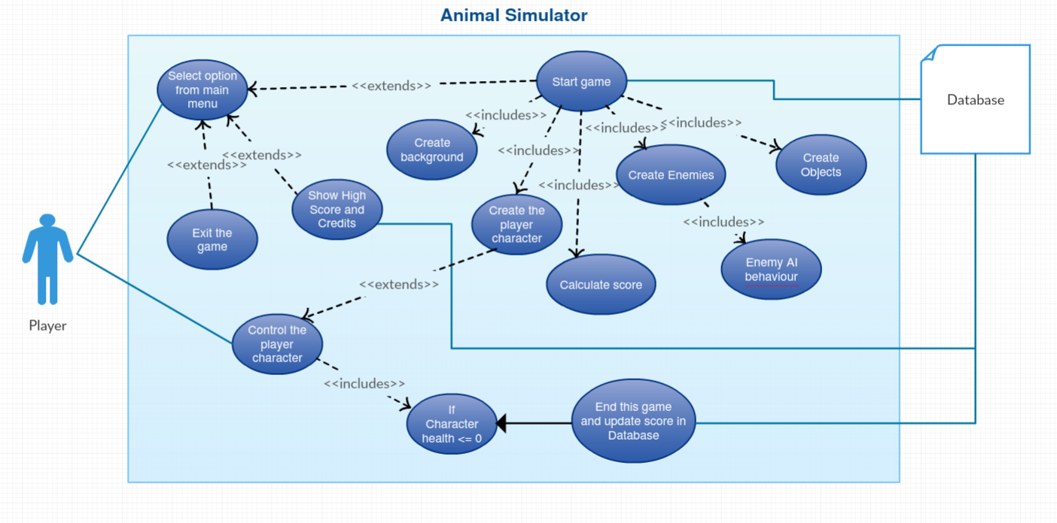

## Feasibility by Mikaela & Aisling

This section describes which technologies are planned to be used in the development of the application. It then explains if there are any issues in terms of the technical feasibility of the project, for example, if there are two different types of software which may have compatibility issues.

TOP 6 TECHNOLOGIES:

1. Unity for game development
2. Visual Studio Code for C# coding
3. Miro for brainstorming ideas
4. Trello for project management
5. Photoshop for designing and prototyping
6. Possibly Blender for 3D modelling (idea maybe)

## Conclusion by Aisling + Mikaela

Write a couple of paragraphs summing up the chapter. Explain what area your project is about. Describe what the chapter has discussed.

Animal Simulator is intended to be an ambitious and fun game that can be enjoyed by casual and serious gamers alike. The project will not be without its obstacles and low points; but, at the end of the day, we hope to create a game that is fun for everyone to play.

**IDEAS:**

<https://www.linkedin.com/learning/unity-2017-architectural-visualization/creating-a-standard-third-person-character>

<https://www.linkedin.com/learning/unity-2017-architectural-visualization/swapping-third-person-characters>

<https://assetstore.unity.com/packages/3d/animations/basic-motions-free-pack-154271>

<https://www.youtube.com/watch?v=IJdidB83aig>

<https://www.youtube.com/watch?v=c4HDfO2W1Nc&t=250s>

<https://www.youtube.com/watch?v=4HpC--2iowE&t=1035s>

https://productcoalition.com/how-to-write-a-simple-yet-effective-requirements-document-bda5bf6623e0